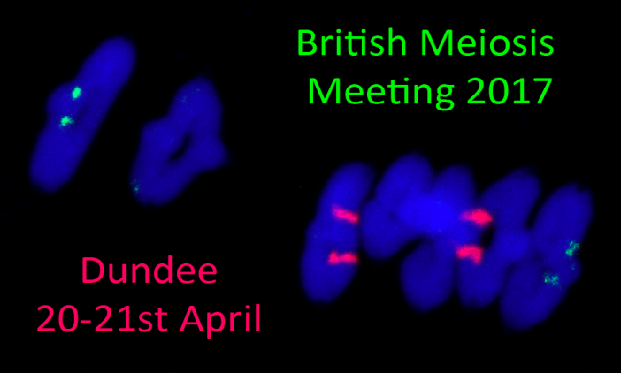
Organizers:

Dr Isabelle Colas
The James Hutton Institute

Dr Alexander Lorenz
University of Aberdeen

20th April 2017
12.00: Registration and Lunch

13.00-13.30: Plenary Speaker: Mathilde GRELON (Institute Jean-Pierre Bourgin, INRA, Versailles, France) : A DNA topoisomerase VI-like complex initiates meiotic recombination

13.40-15.00: Session 1: Genetic and Environmental Determinants of Recombination

13:40: Kayleigh Wardell (University of Sussex): Control of meiotic DNA end-resection by Rad24 in Saccharomyces cerevisiae
14:00: Simon Brown (University of Aberdeen): Delineating the role of Schizosaccharomyces pombe Hop1, a conserved meiosis-specific chromosome axis protein
14:20: Mikel Arrieta (The James Hutton Institute): Influence of temperature on recombination in barley
14:40: Candida Nibau (IBERS, Aberystwyth University): The CDKG1 protein kinase is essential for male meiosis at high ambient temperature

15.00-17.00: Coffee/Tea, poster session, and facilities tour

17.00-18.40: Session 2: Cohesion and Chromosome Segregation
17:00: Daniel Cooney (University of Newcastle) Age associated chromosomal instability in Human Oocytes
17:20: Caitríona M. Collins (The National University of Ireland) A novel nuclear function for mitochondrial ATP synthase F1 subunits during Drosophila male meiosis
17:40: Oana Telecan (Imperial College London) Investigating the different roles of the HORMA-domain protein HTP-1 during meiotic prophase
18:00: Stefan Galander (University of Edinburgh): Establishing meiosis i-specific chromosome segregation
18:20: Mariana Costa (University of Edinburgh): The molecular architecture of the bipolar spindle is remodelled during the long oocyte arrest

19.30 Dinner (Apex Hotel)

21st April 2017
9.00-9.30: Plenary Speaker: Bernard DE MASSY (Institute of Human Genetics, CNRS, Montpellier, France): TBA

9.30-11.00: Session 3: Crossover Control
9:30: Divyashree C. Nageswaran (University of Cambridge): A genetic screen to identify factors that control meiotic recombination in Arabidopsis thaliana
9:50: Joiselle Fernandes (INRA UMR 1318, France): The conserved complex FLIP-FIGL1 negatively regulates meiotic crossover formation.
10:10: Adrian Gonzalo (INRA UMR1318 & UMR1349, France): Crossover MSH4-dependancy varies with ploidy level in Brassica napus meiosis.

10.30-11.00: Coffee/Tea and poster session

11.00-12.00: Checkpoints & Synaptonemal Complex
11:00: James H. Crichton (MRC Human genetics Unit, Edinburgh): Defects in Meiotic Recombination Delay Progression Through Pachytene in Mouse Spermatocytes
11:20: Lucas Pellegrini (University of Cambridge): Biophysical studies of the meiotic protein SYCP3
11:40: James M. Dunce (University of Newcastle): Structural basis of meiotic chromosome synapsis through SYCP1 self-assembly

12.00: Closing comments, BMM 2018 business, lunch and departure

SPONSORS

Become a genetic society member: www.genetics.org.uk

